**KP ENTERTAINMENT CORNER**

Subject: COMPUTER SCIENCE

Name: Prakhar Jain

Class: XII-C

Board Roll.no:

**INDEX**

1. Certificate of Authenticity
2. Acknowledgement
3. Project Synopsis
4. Project Requirements
5. Flowchart/ Project Plan
6. Source Code
7. Sample Output
8. Validations / Limitations
9. Bibliography

**Certificate of Authenticity**

This is to certify that Prakhar Jain bearing Roll No …………….. is a student of Class XII of Sanskriti School.

He has successfully completed his project under my guidance and supervision towards the fulfillment of the practical examination in Computer Science conducted by the Central Board of Secondary Education for the academic year 2015-16.

Date of Submission:

Name of Subject Teacher: Mrs. Anuja Mittal

Teacher’s Signature:

School Stamp:

**Acknowledgement**

We would like to thank Mrs. Anuja Mittal for her valuable guidance, interest and constant encouragement for the fulfilment of the project

**Project Synopsis**

This project is a combination of games and patterns made using python. The games included are Blackjack and Lucky 7. While the 2 patterns incorporated in our project are serpinsky triangle and a hollow triangle. Other than usual python coding for these programs, we have made a logo for our project using turtle function in python and have used our HTML skills to make our code more interactive and used python based hyperlinking to make combine all the codes in one place.

**Source Code**

**Main Code:**

from turtle import *

import Tkinter as logo

import webbrowser

import blackjack

import lucky7

import triangle

import diamond

print "Check out our logo "

def callback(event):

webbrowser.open_new(event.widget.cget("text"))

root = logo.Tk()

lbl = logo.Button(root, text=r"Social.html", fg="red", cursor="target")

lbl.pack()

lbl.bind("<Button-1>", callback)

root.mainloop()

pen1=Pen()

pen2=Pen()

pen1.screen.bgcolor("#B51108")

pen1.color("#FFFFFF")

pen2.color("#532222")

pen2.up()

pen2.goto(-50,50)

pen2.down()

pen1.begin_fill()

pen1.circle(100)

pen1.end_fill()

pen2.write("KP",font=('Candara',70))

pen1.up()

pen1.goto(-250,-150)

pen1.down()

pen1.write("""1. Blackjack

2. Lucky 7

3. Pattern 1

4. Pattern 2""",font=("Candara",20))

while True:

k=input('Enter Choice ')

if k==1:

blackjack.blackjack()

elif k==2:

lucky7.lucky7()

elif k==3:

triangle.triangle()

else:

diamond.diamond()

print ""

x=raw_input('You want to continue here (y/n)? ')

if x=='n':

print "Thank You For Playing"

break

else:

True

**Code for HTML file**

**Main File**

<html>

<body>

<head>

<body bgcolor="pink ">

<basefont color="red">

<marquee><h1>Grade 12th Project</h1></marquee>

<center><img src="logo.png"></center>

<hr color="red"></hr>

<h1 align="center"></h1>

<table border="4" cellspacing=3 cellpadding=6>

<tr>

<th>Name</th>

<th>Class</th>

<th>Registration number</th>

</tr>

<tr>

<td>Prakhar</td>

<td>XII=C</td>

<td> </td>

</tr>

<tr>

<td>Karan</td>

<td>XII-C</td>

<td> </td>

</table>

<ul>

<li><a href="acknow.txt"><button>Acknowledgement</button></a>

<li><a href="speci.txt"><button>Special thanks</button></a>

</ul>

<pre>

</html>

**Acknowledgement File**

Our teacher Mrs.Anuja Mittal helped us a lot through our project

**Special Thanks File**

A special thanks to Ashok Sir

for helping us find all needed resources

**Blackjack**

About:

The game of Blackjack or 21 is by far the most popular table game offered in gambling estabilishments.

The player is asked to draw the top most card of a well shuffled deck of 52 cards, and keep on doing so as per the player’s will. Each type of card holds a particular value. The objective of the game is to get an exact score of 21. However, the player can withdraw if he/she feels that the chances to win are slim.

Scoring system:

Aces :1 point

Jacks, Queens, Kings : 10 points

Numbered cards : Their respective numbered values

import pickle

import random

def blackjack():

n=input('What the total money you have? ')

b=n

print '''Instructions:

You win double the amount you place in a round if you get a 21

While you lose it all in case you dont get a 21

You can leave the game with the money you have anytime'''

x=['A(hearts)','A(diamonds)','A(clubs)','A(spades)', '2(hearts)','2(diamonds)','2(clubs)','2(spades)',

'3(hearts)','3(diamonds)','3(clubs)','3(spades)', '4(hearts)','4(diamonds)','4(clubs)','4(spades)'

, '5(hearts)','5(diamonds)','5(clubs)','5(spades)','6(hearts)','6(diamonds)','6(clubs)','6(spades)',

'7(hearts)','7(diamonds)','7(clubs)','7(spades)', '8(hearts)','8(diamonds)','8(clubs)','8(spades)',

'9(hearts)','9(diamonds)','9(clubs)','9(spades)','10(hearts)','10(diamonds)','10(clubs)','10(spades)'

, 'J(hearts)','J(diamonds)','J(clubs)','J(spades)', 'Q(hearts)','Q(diamonds)','Q(clubs)','Q(spades)'

, 'K(hearts)','K(diamonds)','K(clubs)','K(spades)']

file=open("cards.dat", "wb")

pickle.dump(x, file)

file.close()

file=open("cards.dat", "rb")

cards=pickle.load(file)

file.close()

def blackjack1(cards):

x=random.randint(0,len(cards))

try:

print 'You got a ', cards[x]

except IndexError:

pass

randm=cards.pop(x)

if randm[0] in ['1','J', 'Q', 'K']:

return 10

elif randm[0]=='A':

return 1

else:

return int(randm[0])

while True:

print "Total money with you=",n

t=input('Enter amount for the round ')

if t>n:

print "Insufficent funds"

break

else:

sm=0

loop=0

while loop==0:

if sm==21:

print 'YOU WIN~~!!!!'

print 'Your score->>',sm

t+=(t*(40/100))

n=n+t

break

else:

sm=blackjack1(cards)+sm

print 'Your score->>',sm

if sm==21:

print 'YOU WIN~~!!!!'

print 'Your score->>',sm

t+=(t*(40/100))

n=n+t

break

elif sm>21:

print 'YOU LOOOOSSSSSTTT~~!!'

n=n-t

break

hello=raw_input('Do you want to continue??(Y/N) ')

if hello.lower() in ('y', 'yes'):

continue

elif hello.lower() in ('n', 'no'):

print 'Your score->>',sm

t=t/2

n=n-t

loop=1

break

else:

print 'Error'

print "Another Game? "

a=raw_input("Enter your choice (y/n)[with the remaining cards] ")

if a.lower()=='n':

break

print "Final money with you=",n

print "You have earned ",n-b

**Lucky 7 File**

About:

The game is a simple 2 die game where the player wins if the sum on the die is equal to 7.

The Rules Are:

If you win : You get 4% of your money initial bet

If you lose : You lose 1% of your money initial bet

import random

def lucky7():

print """The Rules Are:

If you win : You get 4% of your money initial bet

If you lose : You lose 1% of your money initial bet

All The Best!"""

mypot = float(input("Please enter the amount of money you want to bet: "))

a=mypot/100

b="y"

while b.lower()=="y":

d1 = random.randint(1,6) #First Diceroll

d2 = random.randint(1,6) #Second Diceroll

sum=d1+d2

if mypot > 0:

if sum == 7:

print "First Diceroll ---> ",d1

print "Second Diceroll ---> ",d2

print "Your roll was a 7 you earned",4*a

print "Balance:", mypot+(4*a)

b=raw_input("Play Again? (Y/N)")

mypot+=(4*a)

else:

print "First Diceroll ---> ",d1

print "Second Diceroll ---> ",d2

print "Sorry you did not roll a 7"

print "Balance:", mypot - a

b=raw_input("Play Again? (Y/N)")

mypot-=a

else:

print "Sorry you do not have no more money in your pot"

break

print "Thank You for Playing"

**Serpinsky Triangle**

import math

def triangle():

n=int(raw_input("Enter the Number : "))

for i in range(0,n+1):

print ""

for j in range(0,i+1):

a=math.factorial(i)/(math.factorial(i-j)*math.factorial(j))

if a%2==1:

print "X",

else:

print " ",

**Hollow Diamond Pattern**

def diamond():

l = int(raw_input("Enter the Number of rows(odd)"))

rows = ['*']

for i in range(1, l, 2):

rows.append('*' + ' ' * i + '*')

rows += rows[:-1][::-1]

align = lambda x: ('{:^%s}' % l).format(x)

diamond = '\n'.join(map(align, rows))

print(diamond)

**Sample Output**

Hyperlinking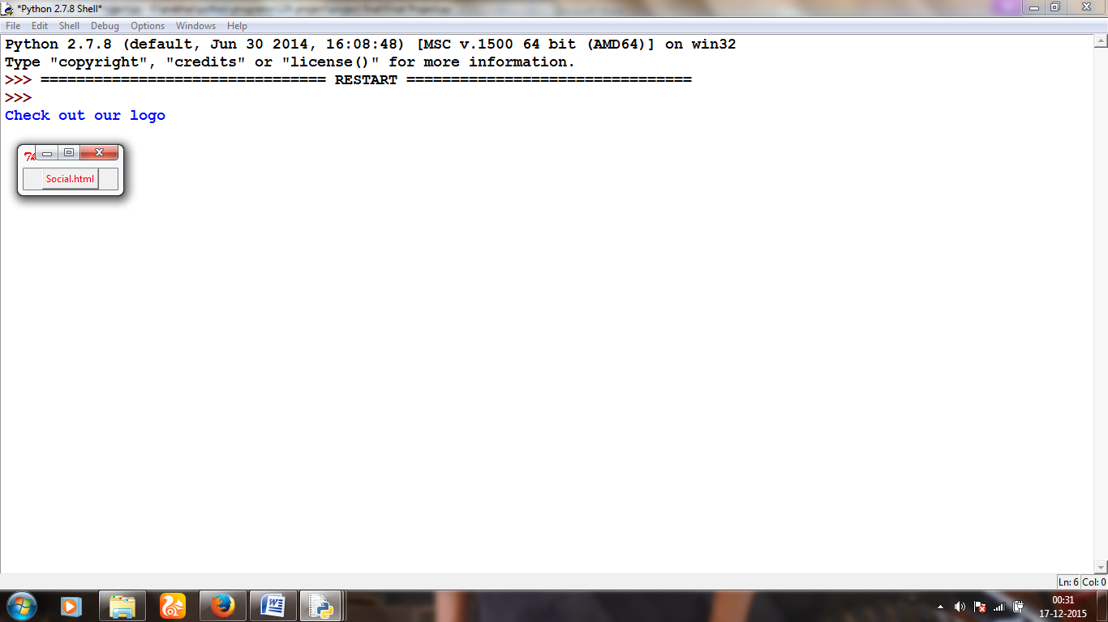

Turtle graphics

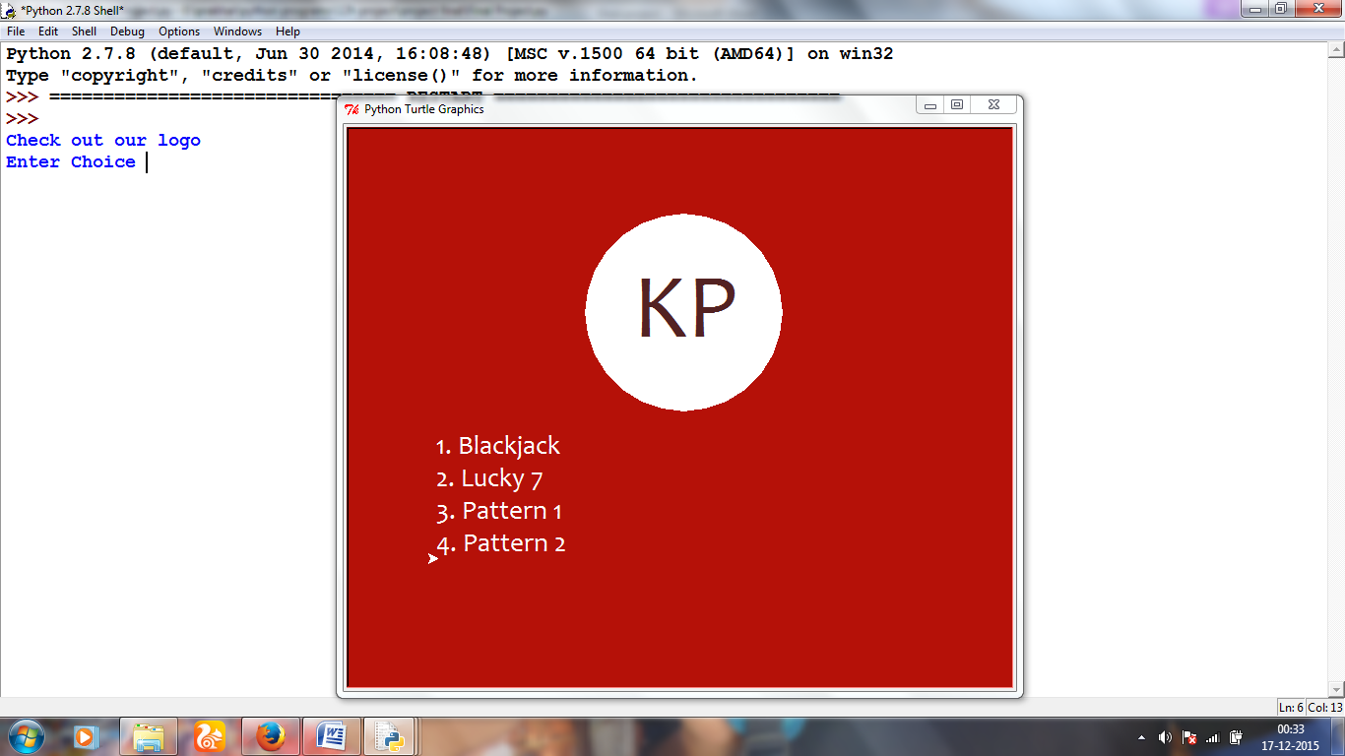

Blackjack

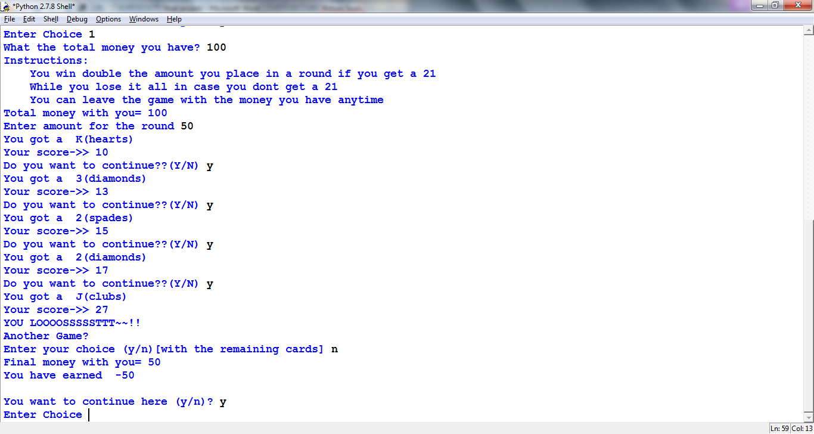

Lucky 7

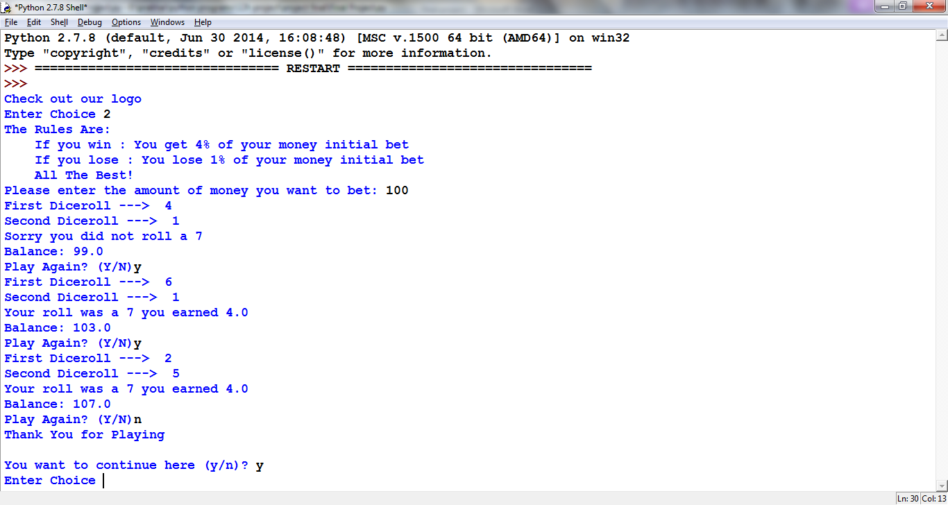

Serpinsky Triangle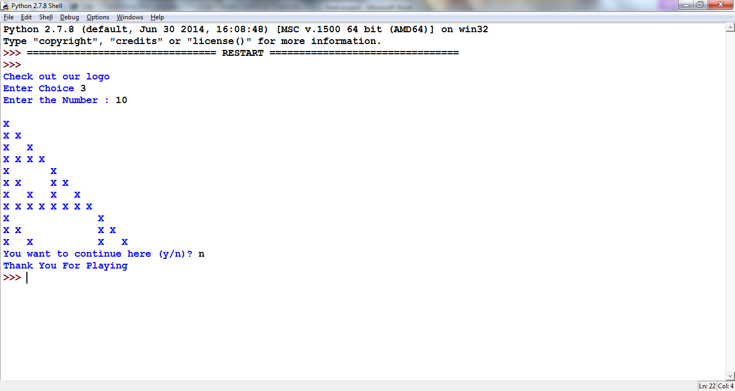

Hollow Diamond

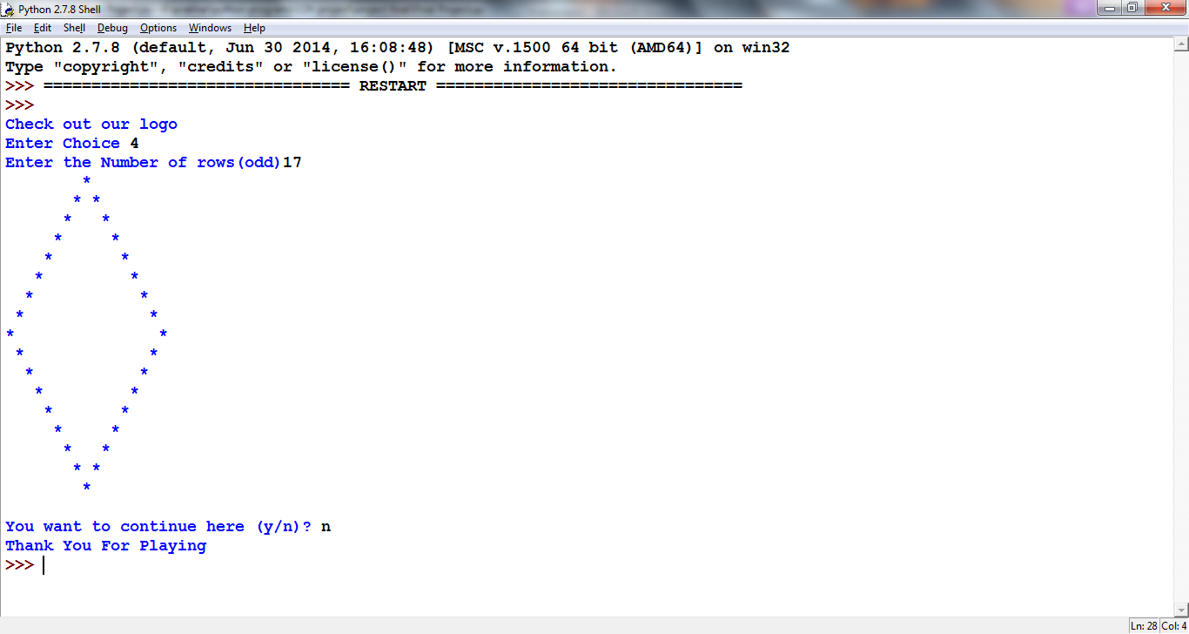

WEB Pages

Home page

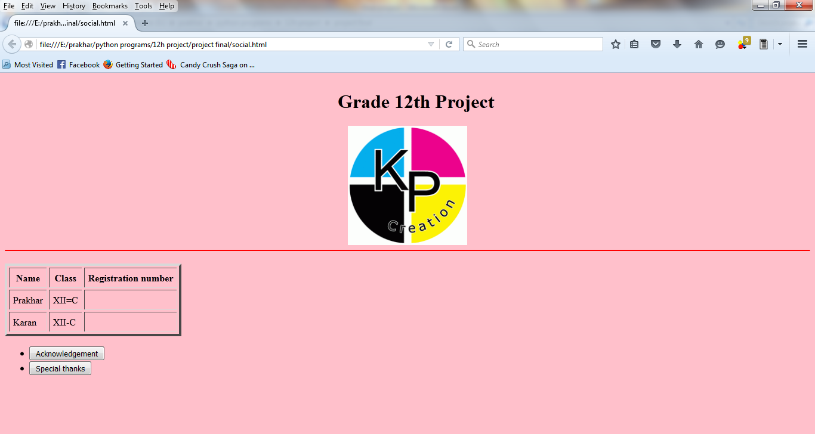

Acknowledgement

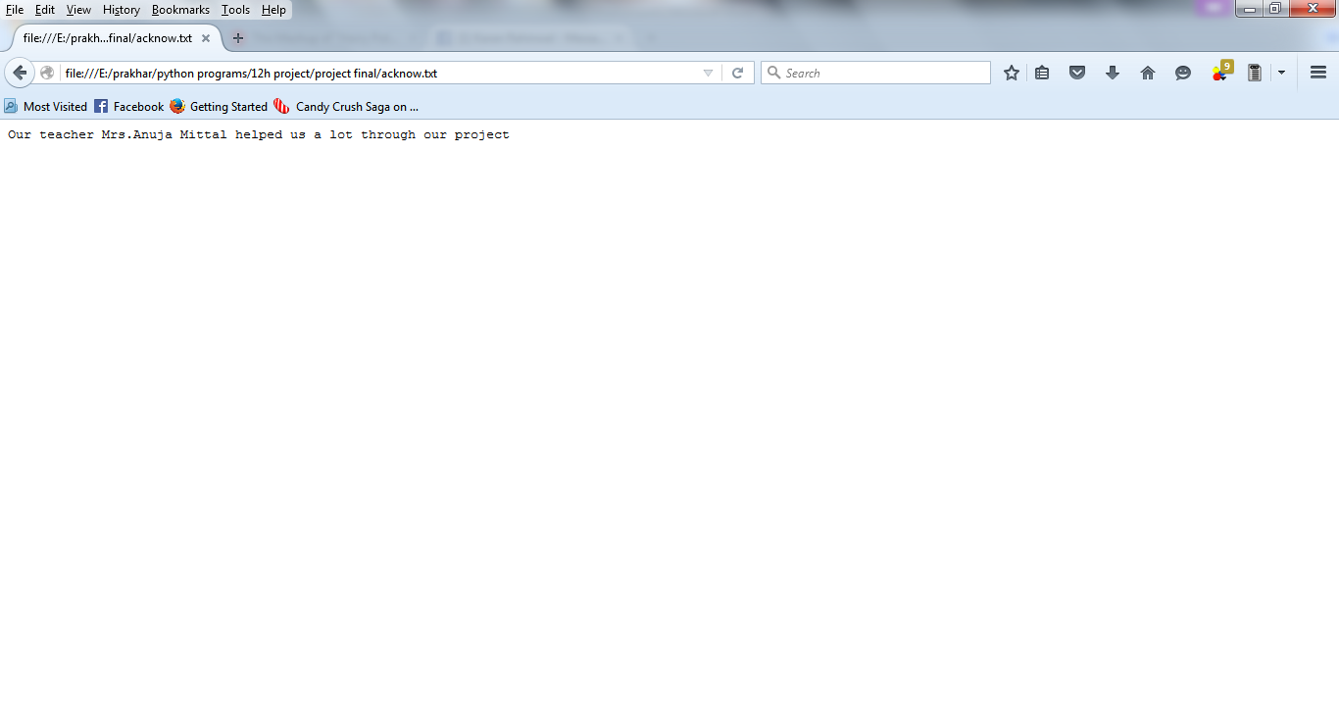

Special thanks

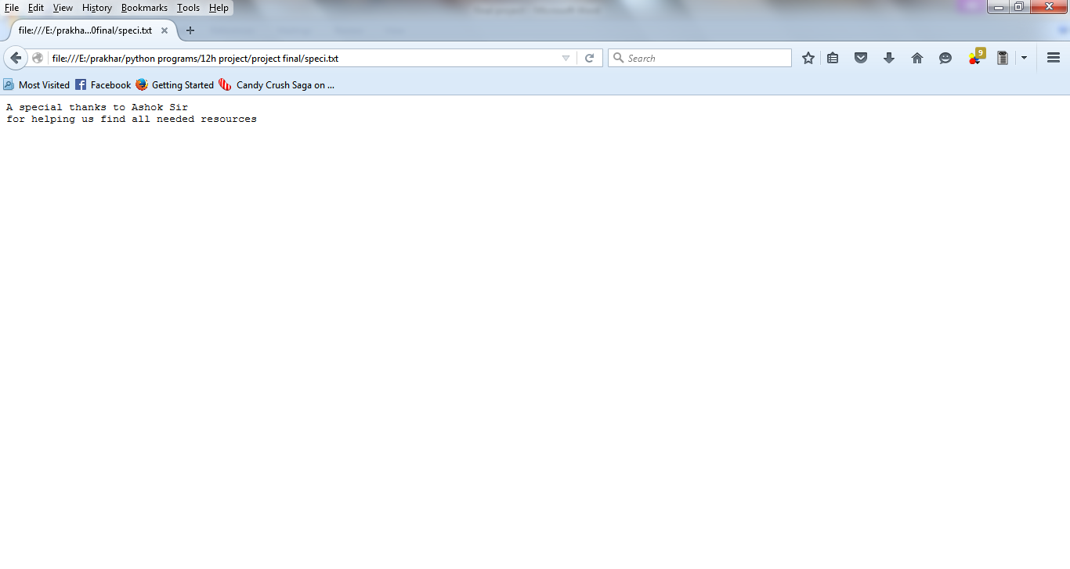

**Bibliography**

1. [https://wiki.**python**.org](https://wiki.python.org)
2. [www.**python**forbeginners.com](http://www.pythonforbeginners.com)
3. [www.secnetix.de/olli/**Python**/](http://www.secnetix.de/olli/Python/)
4. [www.programiz.com/**python**-programming/](http://www.programiz.com/python-programming/)